**1.** Here are some reasons why people apply for new positions. Which ones are not suitable for a

letter of application? Give a reason.

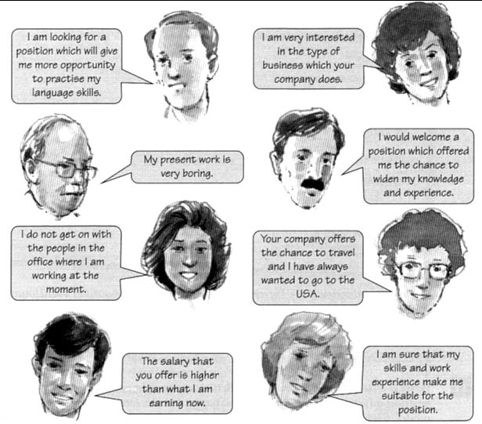

How important are the following things to you? Put them in order (most important first).

| good salary | good career prospects |
| --- | --- |
| pleasant working environment | high social status |
| working in a team | flexible working hours |
| having a challenge | being able to work from home |
| praise from boss/customer/colleagues | take responsibility |

Write down additional things which are not listed but important to you.

1. **A job advertisement**

Daniela Kropp, a newly qualified software developer, is looking for a job on the internet. She is interested in the following advertisement.

Read the advert and underline unknown words and structures. Then complete the sentences below in your own words.

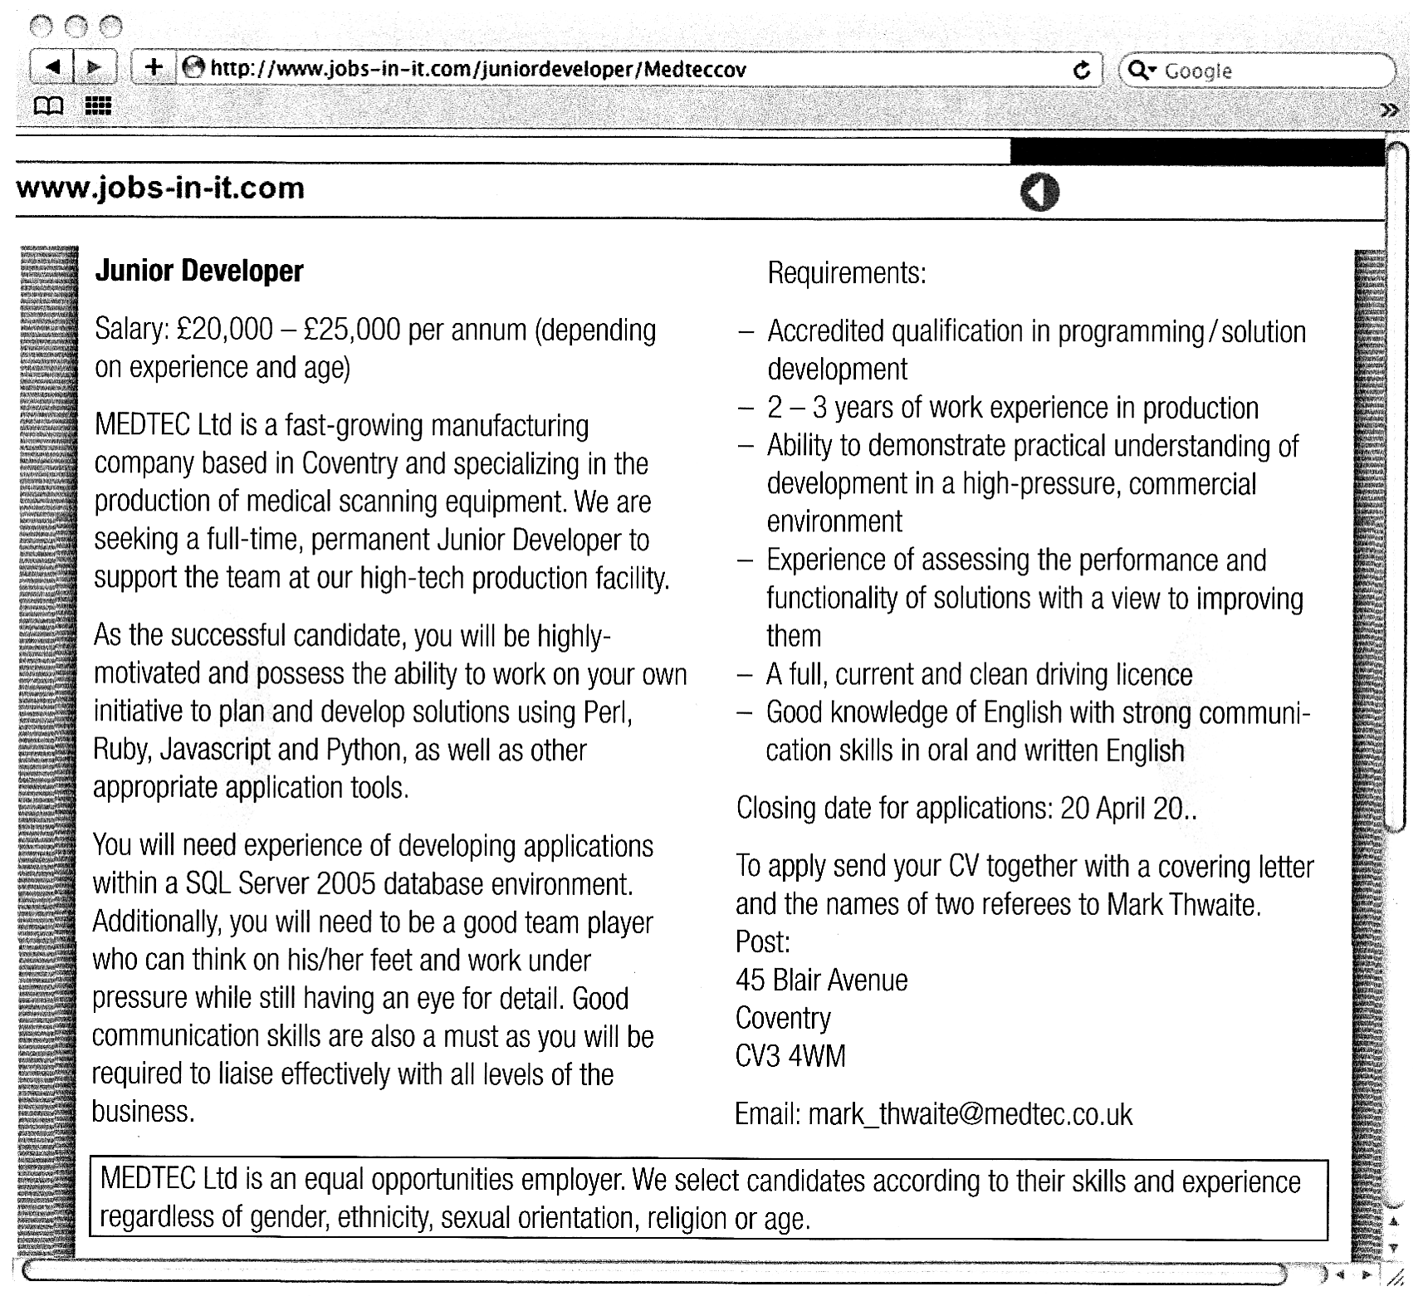

1. The company will pay
2. The type of contract of employment on offer is
3. Candidates should have their applications in by
4. The company’s employment policy says

**4.** Read the ad again and make two lists 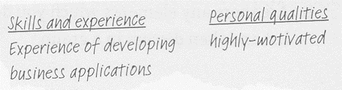

of what the company is looking for

**5.** Match the German expressions (1 – 10) with English ones from the text

|  |  |
| --- | --- |
| 1 abhängig von | 6 eigenständig arbeiten |
| 2 ansässig in | 7 Erfahrung |
| 3 unterstützen | 8 Lebenslauf |
| 4 Berwerber/in | 9 Anschreiben, Begleitbrief |
| 5 Fähigkeit | 10 Referenzen |

**6. Writing an English CV**

a. Read the text and make a list of the things which are different from Germany.



b. Make a list of *dos* and *don’ts* about writing a CV in English.

**7.** **Key Vocabulary: Education and Vocational Training**

Match the English terms in the box (1-8) with their definitions (a-h).

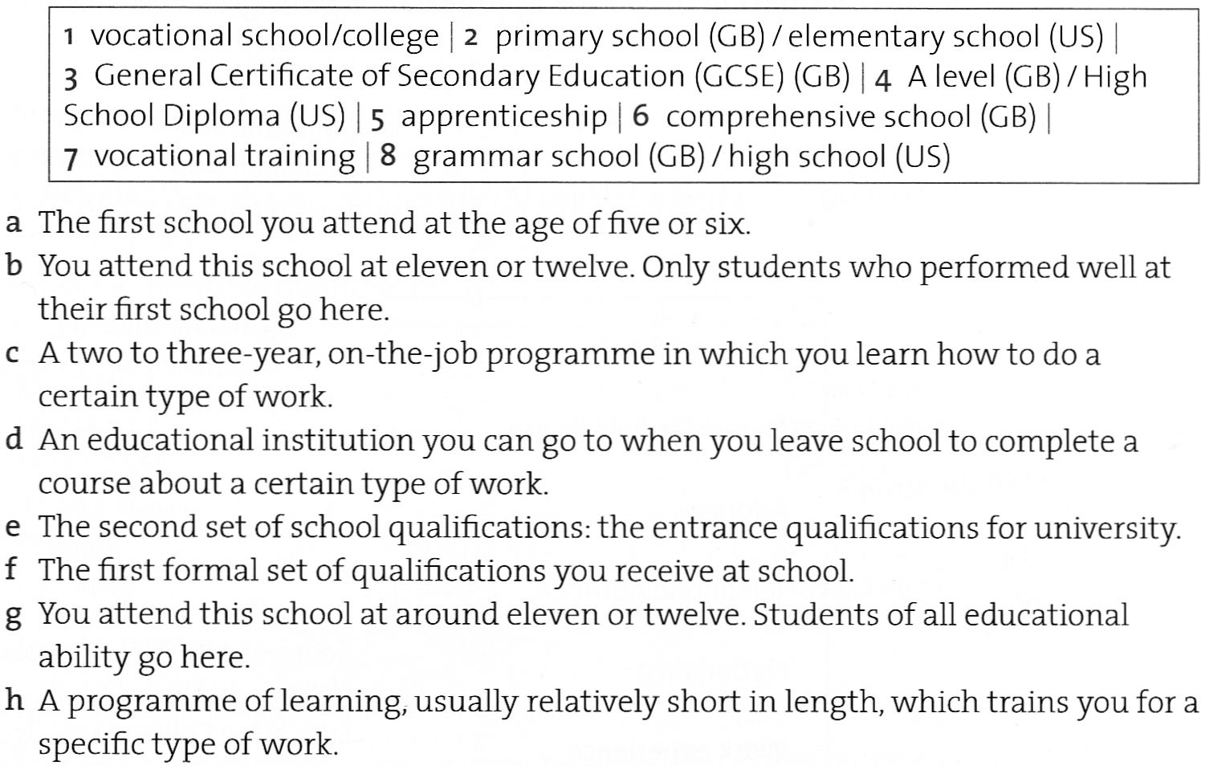

**8.** **Daniela’s CV**

Daniela decides to apply fort he job with MedTec Ltd.

1. Copy the outline of her CV and then write the information under the appropriate headings.

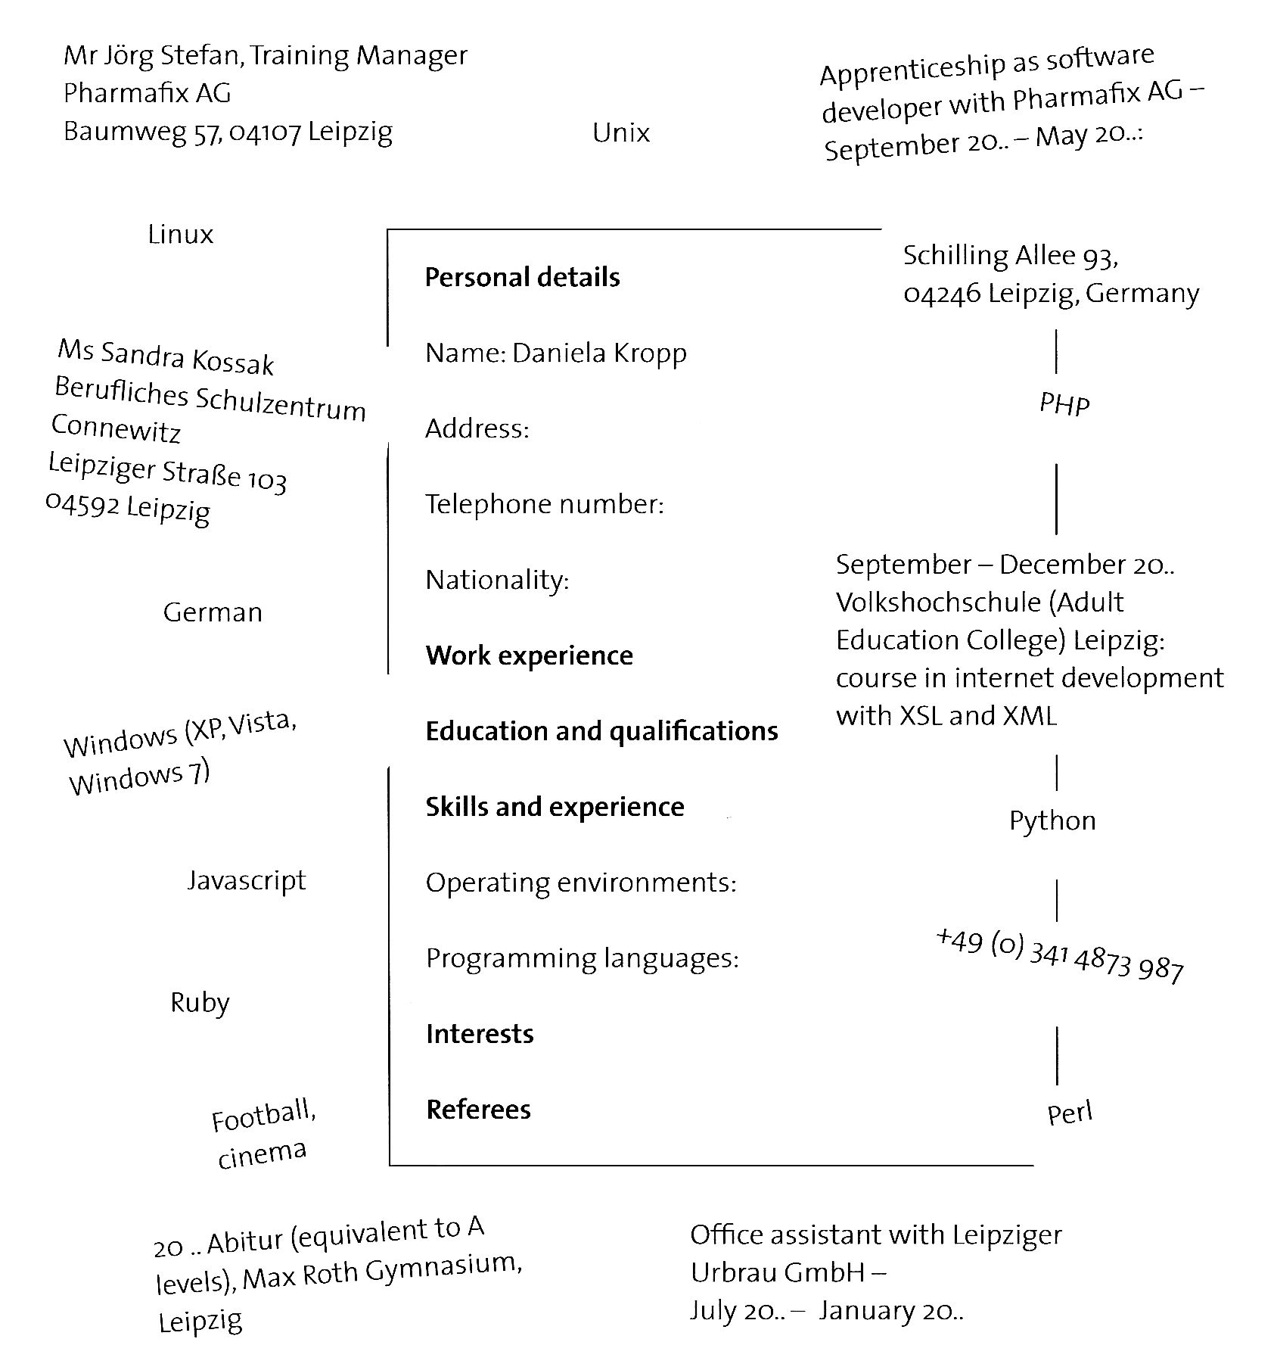

1. Complete your own CV in English using the one above as a guide for your layout and

content.

1. Swap CVs with a partner. Read his/her CV and suggest improvements.